**Introduction**

The species abundance distribution (SAD) is one of the very few ecological patterns whose consistency in shape makes it akin to an ecological law (Lawton, McGill, …). Across varied ecosystems and taxa, the species abundance distribution is nearly always dominated by a few very abundant species and a larger number of increasingly rare species, generating a distinctive hollow- or J-shaped curve (). Tempted by this remarkably general pattern, community ecologists have used the species abundance distribution to test numerous theories designed to determine which biological processes are most important for structuring assemblages of species (). However, using the species abundance distribution to infer underlying processes has proven frustrating because there is so little variation in the shape of this distribution, even in response to experimental manipulations (supp), and many theories produce similar predictions that perform comparably well when compared to observed distributions (McGill).

Ecologists have generally focused on explaining the species abundance distribution as emerging from ecological processes, but accumulating evidence suggests that statistical constraints may be involved in generating the most striking feature of the species abundance distribution – the hollow curve. Mathematically speaking, we can think of an SAD as an unordered vector of S values that sum to N, where S and N are the total number of species and individuals in a community. If our (implicit) null expectation for such a distribution is that it be uniformly distributed, with all species having approximately N/S individuals, the hollow curve we see in nature is indeed surprising and begs for explanation. However, multiple efforts to characterize the most-likely random expectation for the SAD have converged to find that in general, the appropriate statistical baseline for an SAD is in fact *a hollow curve*. Frank () used a statistical mechanics framework to show that hollow curves, including a log-series, can easily be obtained as statistical by-products of [dividing things into things]. Harte and associates () used entropy maximization to find the most-likely form for numerous ecological distributions, given sparse information about broad community properties and minimal assumptions regarding ecological mechanism. They also found that a log-series emerges as the most-likely form for the SAD (). Locey and White (2012) used combinatorics to characterize the range of *possible* forms for SADs, or feasible set, for realistic values of S and N. They showed that practically all feasible sets have strong central tendencies towards hollow curves (). Given minimal assumptions about biological process, and instead using S, N, and our understanding of the most-likely form of a vector with S elements that sum to N, we therefore have good reason to expect most SADs to be hollow curves.

If, as seems to be the case, SADs are statistically driven to be hollow curves before biology even enters the picture, it is no surprise that we have struggled to interpret the hollow curve in biological terms. However, while the general hollow-curve shape may be a statistical artefact, it is still possible that biological processes influence more subtle aspects of the SAD – i.e. that biological processes push the species abundance distribution slightly away from the most likely random outcome. If we can evaluate SADs not in terms of their absolute shape, but in terms of their shape *relative to what we would expect simply due to S, N, and the statistical constraint* (), then we can evaluate theories in terms of how well they predict the *deviations,* or how much additional predictive power they give us beyond what is inherent to S and N. If we cannot distinguish between observed species abundance distributions and their statistically-most-likely forms, there may be little information we can extract from the SAD alone – either because it does not contain appreciable signal of biological process, or because the range of highly-likely forms for the distribution obfuscates that signal.

Our capacity to detect deviations between observations and randomness depends strongly on the characteristics of the range of statistically-likely outcomes, which in turn depends strongly on the size of the system in terms of S and N. Generally, in the study of complex systems, statistical predictions for the most-likely state of a system are most easily derived given the assumption of effectively infinite numbers of subcomponents in the system – for example, atoms of gas in a canister. As the number of particles in the system becomes very large, the set of *possible* states of the system clusters tightly around a single highly-likely state, meaning any other outcome would be a true statistical shock. Unlike canisters of gas, ecological communities do notalways have effectively infinite subcomponents, and “small *n*”problems may limit our ability to make distinctions between observations and random expectations. If there is a narrowly-defined, overwhelmingly most-likely form for a particular SAD, even a relatively small departure from this outcome would be readily detectable and suggestive of a nonrandom process driving the system away from its statistical constraint. However, if the array of possible forms for an SAD is relatively broad and encompasses a range of more equally-probable forms, even observations that deviate from the statistically-driven outcome may not be obviously inconsistent with the random expectation. We expect this situation to be more common in smaller communities, but we do not know the specific values of S and N for which it will be relevant.

We set out to establish if, and in what ways, we can detect consistent deviations between empirical SADs and their statistical constraints. If present, consistently *detectable* deviations would provide new leverage for interpreting SADs in biological terms. Such deviations likely betray non-random processes at work, and we may be able to use the deviations to evaluate theoretical predictions and make comparisons between empirical systems. The *absence* of detectable deviations would not necessarily be evidence of an overall lack of structural processes, but would mean that it is likely to be quite difficult to extract biological information from the SAD. Especially if such a lack of detectable deviations corresponds with small communities with relatively vaguely-constrained SADs, we suspect it reflects the limits of our ability to make confident statistical distinctions in those contexts.

For SADs from a range of communities spanning X Y and Z taxa, we characterize the statistically-most likely forms for the SAD based on the number of species and number of individuals, and the relative specificity or vagueness of this statistical constraint. We then compare *observed* SADs to their corresponding statistical baselines and test 1) whether observed SADs are consistently unusual given their statistical expectations, and 2) whether our ability to detect deviations seems to vary systematically over broad gradients in *S* and *N* and corresponding variation in the narrowness of the statistical constraint.

**Methods**

*Datasets*

We use a compilation of datasets of community abundances for trees, birds, mammals, and miscellaneous other taxa that has been used in recent macroecological explorations of the feasible set (White et al 2012, Baldridge et al 2014). It includes data from trees in the Forest Inventory and Analysis and Gentry plots, birds in the North American Breeding Bird Survey, the Mammal Community Abundance Database, and a variety of less commonly sampled taxa in the Miscellaneous Abundance Database.

For datasets with observations from multiple years, we followed White et al (2012) and Baldridge et al (2014) and analyze only a single year of data. The Mammal Community Abundance Database and Miscellaneous Abundance Database include data collected over longer timescales that cannot be disaggregated, with an average temporal scale of X.

*the statistical constraint*

Following Locey and White (), we use combinatorics to characterize the statistical constraint on the SAD. For any given number of individuals *N*,there is a finite set of unique ways to partition those individuals into *S* species. The full set of *possible* SADs for a given S and N is the “feasible set”. A uniform sample of elements from the feasible set reflects the distribution of possible forms for an SAD, and – to the extent to which the elements of the feasible set converge towards one overall shape – shows us both the shape of the most-likely form and the narrowness of the constraint. U

Sampling the feasible set is impractical for very large or very small communities. It is computationally intractable to sample the feasible set for very large communities, and very small communities have too few elements in their feasible set for our approach to be truly applicable (see below). The size of the feasible set varies as a function of S, N, and the ratioof N to S; communities with many individuals, many species, and a high ratio of N:S have the largest and least tractable feasible sets. We therefore filtered our datasets to remove communities with more than X species or X individuals, or fewer than 2 species or X individuals. Additionally, the FIA database contains roughly 100,000 communities. Of these, approximately 90,000 have fewer than 10 species and X individuals. Rather than analyze all of these small communities, we randomly selected 10,000 small communities to include in the analysis. In all, we analyzed X communities encompassing X taxa, with S and N ranging from 2 to X and X to X, respectively.

*Effects of S and N on the size and central tendency of the feasible set*

To show how the specificity of the central tendency varies over S and N, we measured the self-similarity of elements of the feasible sets for combinations of S and N spanning the ranges represented in our compilation of datasets. For each S and N combination, we drew a maximum of 4000 unique samples from the feasible set. We then randomly drew a maximum of 4000 pairs of SADs from each set of samples and calculated four measures of similarity between each pair: a direct calculation of R2 common in macroecology [R2 formula], the coefficient of determination from a linear model fitting one sample to the other, the proportion of individuals allocated to different species, and the K-L divergence. Each of these measures has its imperfections, but the four measures all give qualitatively the same outcomes. Note that, for small communities, both the number of unique elements in the feasible set and the number of possible pairwise combinations of elements can be considerably lower than 4000. We take the mean value of each of these measures as a rough measure of the specificity of the statistical constraint for that community.

*Comparing observed SADs to their feasible sets*

We compare the forms of observed SADs to their feasible sets by establishing a distribution of summary statistics for the SADs present in the feasible set and comparing the summary statistic values for the observed SADs to these distributions. We used skewness and Simpson’s evenness as our summary statistics, and calculated the percentile rank of the value for each observed SAD compared to the distribution of values obtained from its feasible set. Skewness can be calculated multiple ways, but using different formulas yields qualitatively identical results. It cannot be calculated for SADs with fewer than three species, and it is infinite in the special case where every species has the same number of individuals. Simpson’s evenness does not have these idiosyncrasies.

The range of values we observe for both statistics depends on S and N, so in order to synthesize across communities with different S and N we must focus on the percentile value, rather than on the raw values of the statistics. We calculated percentile rank as the percent of values in the distribution less than or equal to the observed value. Note that the precise meaning of this value differs subtly depending on whether the distribution of samples from the feasible set represents a true distribution of *samples* or an exhaustive account of all elements in the feasible set. If the samples are exhaustive, the percent of samples <= to the observed value may be 100, but can never be 0 – even if the observed value is the lowest value possible, it is still <= itself. However, if sampling is not exhaustive, we may obtain a percentile value of 0 if the observed value is less than the lowest value we came across via sampling.

At random, we would expect the percentile values to be uniformly distributed from 0 to 100. If observed SADs are consistently more skewed or even than their feasible sets, the percentile values will be nonuniform. If, as we suspect given our reasoning about the central tendency (above), smaller communities have less defined central tendencies, we may not detect consistent deviations from randomness in those communities. To show how the strength of the central tendency may inform our results from actual datasets, we repeated the self-similarity analysis (above) for every S and N actually represented in our database. We present results for percentile values aggregated over all datasets, and subset according to the size and range of variation of the feasible set.

*Effects of rarefaction*

Whenever we survey the species present in a real system, we are likely miss some species – particular rare or cryptic ones. To test whether adding these presumably-present but unaccounted-for species affects our results, we ran our analyses on both raw data and on SADs adjusted via rarefaction. For each raw SAD, we took the mean number of estimated species from [] richness estimators, and added species to reach this mean estimated richness. We reasoned that species missed during sampling are likely to be rare, and added a single individual each for each added species. This allowed us to explore the consequences of rarefaction while making the smallest possible changes to S and N.

**Results**

*Effects of S and N on the narrowness of the statistical constraint*

Across the range of S and N we sampled, the number of elements in the feasible set increases rapidly with S, N, and N/S (Fig 1). Most feasible sets, but especially large feasible sets and feasible sets for communities with a low N/S ratio, are highly self-similar by any measure (Fig 2, Fig 3). High self-similarity for large communities is consistent with our expectations based on intuition from statistical mechanics (above). Although communities with a low N/S ratio have small feasible sets for their number of species, low average abundance forces all elements of the feasible set to be fairly even and reduces their variability compared to similarly sized but less restricted feasible sets. Self-similarity, and therefore the narrowness of the statistical constraint, declines for communities with fewer than roughly [n] elements in the feasible set. These are communities with up to S species and N individuals, which are hardly uncommon in nature. To the extent that relatively vague constraints interfere with our ability to detect constraints, the SAD may informative primarily for very large ecological communities.

*Observed SADs relative to their constraints*

Overall, we see a definite, but not overwhelming, overrepresentation of high scores for skewness and low scores for evenness for observed SADs compared to their feasible sets (Fig 4, Fig 5). Overall, 6.8% of observed SADs are more skewed than 95% of their feasible set, and 14% are less even than 95% of their feasible sets; by chance we would expect only 5% of observed FS to fall in these ranges.

The strength of this result depends strongly on the size of the feasible set (Fig 7, Fig 9) and the self-similarity of the feasible set (Fig 6, Fig 8), which are tightly coupled. The distributions of percentile scores for empirical SADs with large feasible sets – which tend to be highly self-similar – are obviously non-uniform, but this pattern is less pronounced for smaller – and generally less self-similar – feasible sets. For skewness, the non-uniformity disappears entirely for small feasible sets: for the 70% smallest feasible sets, only an average of 3% of observed SADs are more skewed than 95% of their feasible sets, but for the 30% largest feasible sets, 15% of observed SADs are similarly skewed. The overrepresentation of very low evenness scores is more consistent across feasible set sizes, but is also more pronounced for larger feasible sets. For the smaller 70% of feasible sets, 9% of SADs are lesseven than 5% of their feasible set. For the largest 30%, 25% of SADs are highly uneven (Table 1).

*Effect of rarefaction*

SADs corrected for rarefaction are almost always *more* unusual, if anything, compared to their feasible sets than the raw distributions. In nearly all communities, the rarefied percentile value for evenness is lower than for the raw distribution, and the percentile value for skewness is higher than the raw one (Fig 10, Fig 11). For evenness, this outcome is consistent across almost all feasible sets and does not vary with the size of the feasible set (Fig 12). Outcomes for skewness are more variable; some SADs do become *less* comparatively skewed when corrected for rarefaction. This is most pronounced for small feasible sets (Fig 13) and communities that are species-rich but have low average abundance (Fig 14). These communities are unusual in that all elements of their feasible sets must be quite uneven. Correcting for rarefaction, overall 10% of SADs are more skewed than 95% of their feasible sets (Fig 15), and 20% are less even than 95% of their feasible sets (Fig 16). High skewness values are overrepresented for the largest 70% of feasible sets – rather than only the largest 30% for uncorrected distributions – and low evenness values are overrepresented across all feasible set sizes (Table 2). This may be an artefact of our decision to add new species as singleton species, because adding singletons to a distribution without changing the rest of its shape necessarily increases skewness and decreases evenness.

**Discussion**

SADs for large communities consistently deviate from their statistical constraints, but this is by no means a rule, and we do not detect these deviations for smaller, less narrowly-constrained, communities.

– but note that it is hardly uncommon for the observed SAD to fall well within our random expectation. This range of variation in *deviation* between observation and random expectation may provide new leverage for evaluating theory and drawing contrasts between communities. If a theory can correctly predict whether a community will or will not deviate, or better still the magnitude of the deviation, it is telling us considerably more than we would be able to infer from S and N alone. Similarly, we may be able to identify differences between communities that determine whether their SADs are detectably different from the constraint.

For a substantial proportion of relatively small communities, we do not detect any consistent deviation from randomness. It is technically possible that these small communities differ in some substantive way from large communities, and that small communities are effectively random while large ones are structured by some strong nonrandom process. However, we think it more likely that our failure to detect deviations for small communities is simply a reflection of the underlying characteristics of the statistical constraints on these communities. Generally, small systems are problematic for approaches inspired by statistical mechanics, as ours is here. The statistically most-likely state for these systems is relatively broadly defined, and this can make even nonrandom outcomes difficult to distinguish from outcomes that could reasonably emerge at random. These “small-n” considerations seem to be relevant for a fairly large subset of ecological communities. Unless we can develop finer methods for detecting deviations, or a lack thereof, for these small communities, we should expect to learn the most by focusing on SADs from relatively large communities.

The SAD is a case study that illustrates how important it is to consider statistical baselines when we interpret “patterns” in ecology and especially macroecology. Like all ecological distributions, the SAD emerges from a suite of biological *and statistical* processes. In this case, the statistical constraint on the SAD undermines our intuition for what constitutes a surprising outcome for the distribution. If our implicit null expectation for the SAD is an equal division of individuals among all species, the observed hollow curve is highly surprising and begs for an explanation. However, considering the actual landscape of probable forms for the SAD, we find that the hollow curve alone is not a remarkable observation, but that there are more subtle patterns of variation that we *cannot* attribute to randomness alone.

It is relatively intuitive to demonstratethis phenomenon for the SAD, but the general principle may be equally important for other, less tractable, distributions. Because the SAD involves partitioning discrete values into distinct categories, the statistical constraint is relatively simple and can be characterized using combinatorics. Defining and accounting for the statistical constraints on more complex distributions – such as the distribution of biomass among species, or energy use over body size categories – poses additional challenges and may necessitate borrowing tools from other disciplines. If the SAD is any indication, rising to those challenges and incorporating the statistical baseline into our analyses of other ecological “patterns” is both necessary and richly informative.

**Figures**

##### Figure 1: S0, N0, lognparts for range of S*N space



##### Figure 1.5: Datasets in S*N space



##### Figure 1.75: Nparts for datasets



##### Figure 1.875: Nparts by S, N, N/S



##### Figure 2: Self-similarity over S*N space



##### Figure 3: Self-similarity vs. nparts, N/S



##### Figure 3.5 Self similarity for datasets



##### Figure 4: Overall percentile scores for skewness



##### Figure 5: Overall percentile scores for evenness



##### Figure 6: Skewness broken out by ROV metrics

ROV metrics binned into quantiles. So each histogram accounts for 20% of communities. The “1” panel for mean_cd is the 20% of communities with the lowest cd scores, etc.

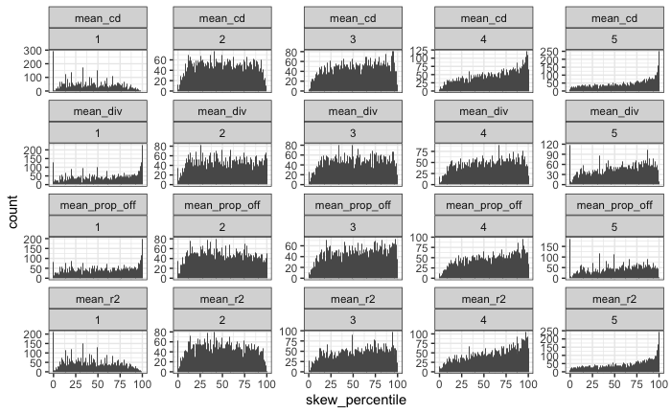

##### Figure 7: Skewness broken out by thresholded size of FS

Size of FS is broken into 10 bins by quantile. Facet labels are the maximum lognparts for that facet; so the 4.7 one is the 10% of communities with exp(3.5) – exp(4.7) parts.

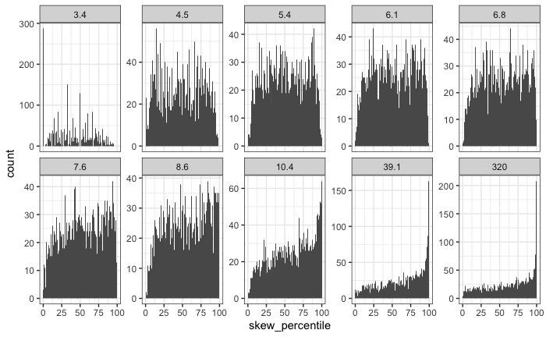

##### Figure 8: Simpson versus ROV

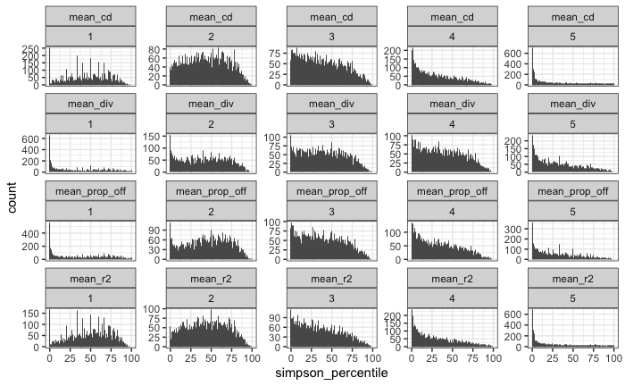

##### Figure 9: Simpson vs size of FS

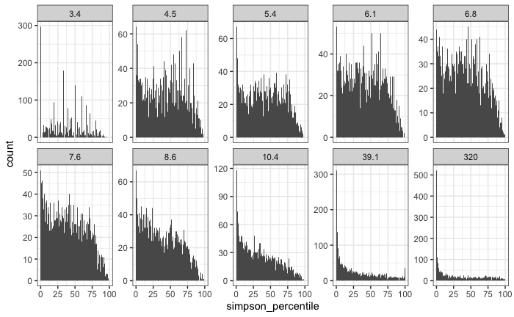

##### Figure 10: Skewness rarefaction change overall

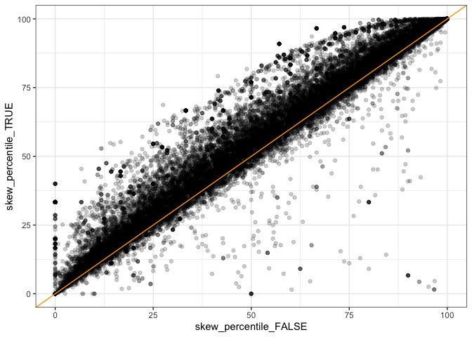

##### Figure 11: Simpson rarefaction change overall

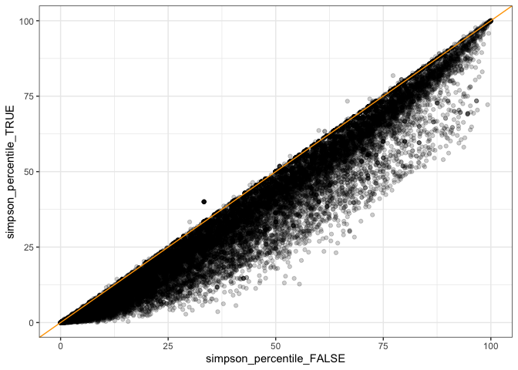

##### Figure 12: Simpson rarefaction by size of FS

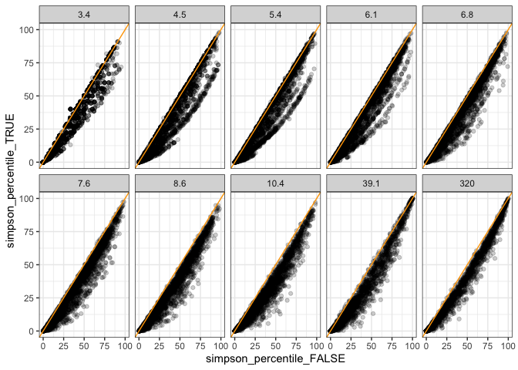

##### Figure 13: Skewness rarefaction change by size of FS

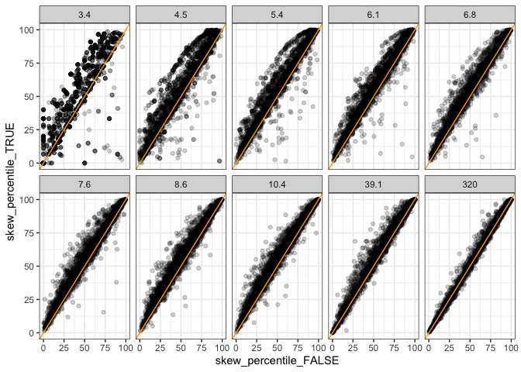

##### Figure 14: Skewness rarefaction change by S and N Green = rarefaction made the skewness percentile score go *down*

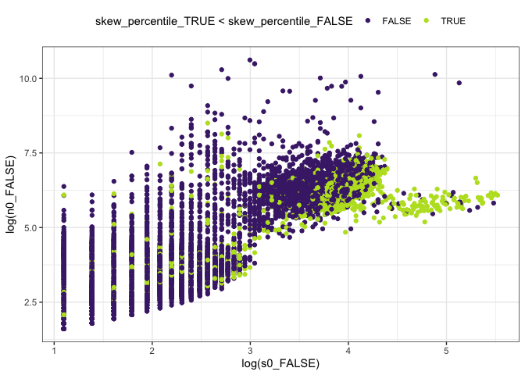

##### Figure 15: Rarefied skewness overall

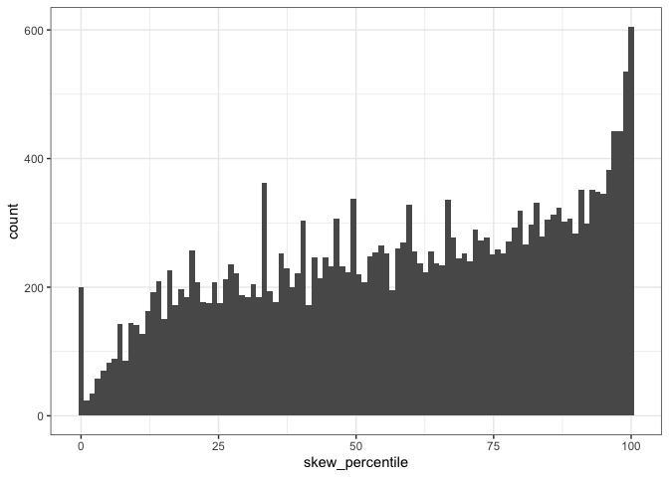

##### Figure 16: Rarefied evenness overall

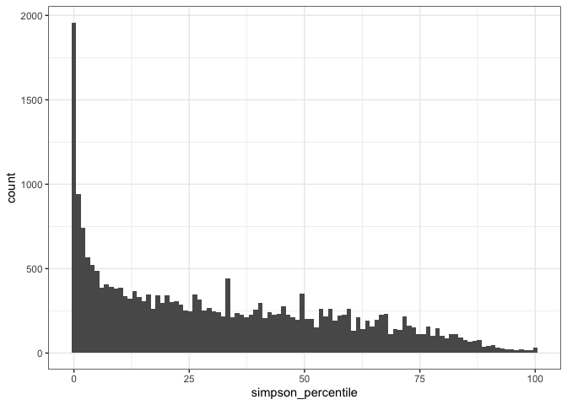

##### Table 1: Proportion of high/low %ile scores for raw vectors

Each qbin (**q**uantile **bin**) contains 1/10 of the communities, divided according to their number of parts. The bin cutoffs are the quantile values, and the bins are labeled according to their ceiling. So bin 3.4 is communities with up to exp(3.4) elements of the feasible set; bin 4.5 is communities with exp(3.4) – exp(4.5) elements, etc.

|  |  |  |  |  |
| --- | --- | --- | --- | --- |
| **qbinned_lognparts**  <ord> | **high_skew**  <dbl> | **Mean % high skew** | **low_simpson**  <dbl> | **Mean % low simpson** |
| 3.4 | 0.002145002 | 0.032 | 0.14671815 | 0.093 |
| 4.5 | 0.005966587 | 0.08711217 |
| 5.4 | 0.021093414 | 0.08824796 |
| 6.1 | 0.031839623 | 0.07311321 |
| 6.8 | 0.049509002 | 0.07692308 |
| 7.6 | 0.052173913 | 0.08737060 |
| 8.6 | 0.064155629 | 0.09478477 |
| 10.4 | 0.102647658 | 0.1505 | 0.14582485 | 0.251 |
| 39.1 | 0.173913043 | 0.27358491 |
| 320 | 0.175164474 | 0.33429276 |

##### Table 2: Proportion of high/low %ile scores with rarefaction

| **qbinned_lognparts**  <ord> | **high_skew**  <dbl> | **Mean % high skew** | **low_simpson**  <dbl> | **Mean % low simpson** |
| --- | --- | --- | --- | --- |
| 3.7 | 0.01030928 | 0.067 | 0.14144330 | 0.134 |
| 4.9 | 0.04293688 | 0.09832546 |
| 5.7 | 0.04755614 | 0.10171731 |
| 6.5 | 0.06222386 | 0.10456554 |
| 7.3 | 0.09323432 | 0.14975248 |
| 8.1 | 0.10764174 | 0.16269515 |
| 9.2 | 0.10412413 | 0.18089016 |
| 11.2 | 0.15765766 | 0.193 | 0.27027027 | 0.36 |
| 40.1 | 0.22764561 | 0.40401969 |
| 331.5 | 0.19491178 | 0.40664752 |